Assignment 6

Retrieval-Augmented Generation (RAG) - Machine Learning Knowledge Assistant

1. Introduction
The objective of this assignment is to build an end-to-end Retrieval-Augmented Generation (RAG) system using a Machine Learning book in PDF format as the knowledge source.
The system is designed to retrieve relevant information from the book and generate accurate, context-based answers for technical questions related to Machine Learning and Deep Learning.
Unlike normal Large Language Models (LLMs), RAG improves answer quality by combining document retrieval with answer generation. This helps reduce hallucination and ensures that responses are grounded in the uploaded document.

2. Dataset Description
The dataset used for this project is a PDF version of a Machine Learning book:
Introduction to Machine Learning with Python
The PDF contains structured knowledge about various Machine Learning and Deep Learning concepts such as:
- Supervised Learning
- Unsupervised Learning
- Neural Networks
- Gradient Descent
- Decision Trees
- Model Evaluation
- Overfitting and Underfitting
- Deep Learning Fundamentals
The PDF acts as the knowledge base for the RAG system.

3. Data Preprocessing
To prepare the PDF for retrieval and answer generation, the following preprocessing steps were performed.

3.1 PDF Loading
The document was loaded using the PyPDFLoader() utility from LangChain.
This process extracts text from each page of the PDF and stores it as structured document objects for further processing.
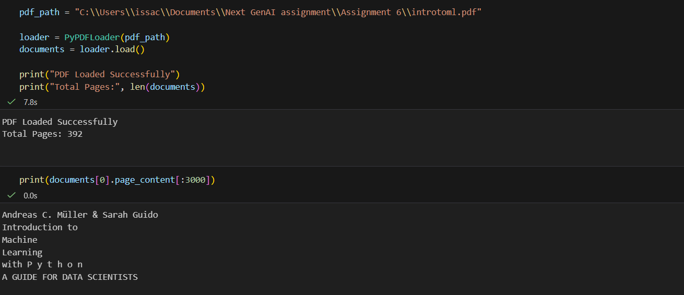

3.2 Text Quality Analysis
The extracted content was manually inspected to evaluate:
- text readability
- formatting consistency
- encoding issues
- missing or broken content
- extraction quality

3.3 Text Chunking
Since large documents cannot be processed efficiently as a single text block, the extracted content was divided into smaller overlapping chunks using RecursiveCharacterTextSplitter().

Configuration Used
- Chunk Size: 500
- Chunk Overlap: 50

Purpose of Chunking
Chunking improves retrieval quality by:
- preserving semantic meaning
- reducing information overload
- improving embedding precision
- enabling accurate similarity search

Purpose of Overlap
Overlap preserves continuity between adjacent chunks and prevents the loss of important contextual information across chunk boundaries.

4. Embedding and Vector Database
This stage converts textual content into searchable vector representations and stores them in a vector database for semantic retrieval.

4.1 Embedding Model
The embedding model used in this project is: sentence-transformers/all-MiniLM-L6-v2
This model converts each text chunk into dense vector embeddings that capture semantic meaning rather than exact keyword matching.

4.2 Vector Database
The vector database used is:

FAISS (Facebook AI Similarity Search)
FAISS stores all generated embeddings and enables high-speed similarity search.

Advantages of FAISS
- efficient nearest-neighbour search
- optimized vector retrieval
- fast local execution
- scalable architecture for large documents
The vector database was created using:
FAISS.from_documents()

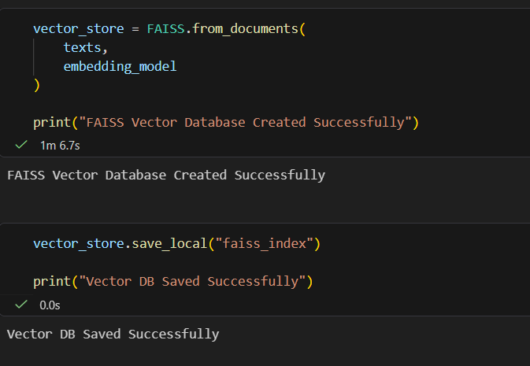

5. Retrieval Pipeline
The retrieval pipeline identifies the most relevant document chunks for a given user question before answer generation begins.

5.1 User Query Input
The system accepts natural language queries such as:
- What is supervised learning?
- Explain overfitting in machine learning
- What is gradient descent?
This enables intuitive interaction without requiring technical query formatting.

5.2 Query Embedding
The input query is converted into vector form using the same embedding model used for document chunks.
Using a shared embedding model ensures consistency between stored knowledge and incoming questions, improving retrieval relevance.

5.3 Similarity Search
The system retrieves the most relevant chunks using:
similarity_search(query, k=3)
This performs semantic similarity matching between the user query and stored document embeddings.

5.4 Top-k Retrieval Strategy
The parameter k represents the number of most relevant chunks retrieved before answer generation.

Example
k = 3
This means the system retrieves the top three most relevant chunks from the vector database.

6. Answer Generation
After retrieval, the selected document chunks are passed to a Question Answering model for grounded response generation.

6.1 Model Used
Hugging Face Model: distilbert-base-cased-distilled-squad
This is an extractive Question Answering model trained specifically for answering questions from provided context.

6.2 Reason for Model Selection
This model was selected because it offers:
- strong performance in question answering tasks
- grounded answer extraction
- lower hallucination risk
- fast inference speed
- reliable local execution without API dependency

6.3 Grounded Answering Strategy
The system follows a three-step process:
- Retrieve the most relevant chunks
- Use the retrieved content as answer context
- Extract the most relevant answer span

Example

Question: Explain overfitting in machine learning

Retrieved Answer: models that are very complex and highly overfit to the training data

Final Improved Answer: Overfitting occurs when a model learns the training data too closely, including noise and unnecessary patterns. This causes the model to perform very well on training data but poorly on unseen data, reducing its ability to generalize effectively.

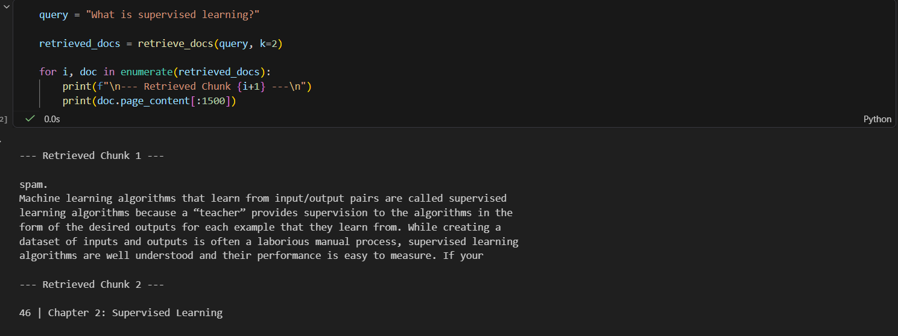
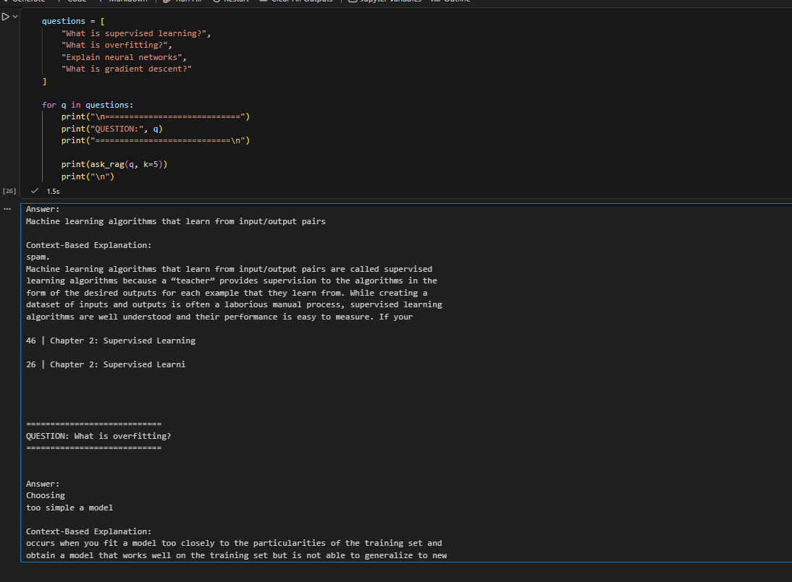
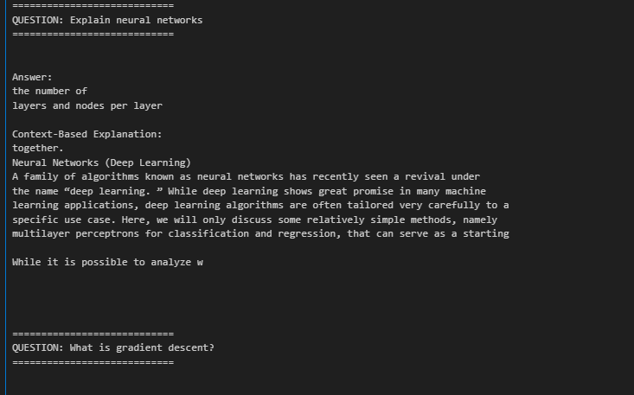

7. End-to-End Application
The final system was implemented as an interactive real-time Question Answering application.
The application continuously accepts user queries using a loop-based interface and returns grounded answers until the user exits the session.

Example Questions
- What is supervised learning?
- Explain neural networks
- What is gradient descent?
- What is overfitting?
- Explain decision trees

8. Model Evaluation
The system was tested using multiple technical questions extracted from the Machine Learning book.

Evaluation Observations
- relevant chunks were retrieved successfully
- answers remained grounded in source content
- overfitting and supervised learning questions produced accurate results
- increasing k improved answer richness and explanation quality

9. Conclusion
This project successfully implements a Retrieval-Augmented Generation (RAG) system for Machine Learning knowledge assistance.
The system combines:
- document understanding
- semantic embeddings
- vector similarity search
- context-grounded answer generation
to create a reliable domain-specific Question Answering assistant.
Compared to direct LLM-based generation, this approach provides:
- higher answer accuracy
- lower hallucination
- stronger explainability
- reliable document grounding

